1. INTRODUCTION

1.1 OVERVIEW

VISUAL REPRESENTATION OF TRAGEDY OF FLIGHT

* Comparing abroad Vs fatality Vs ground
* Max accidence based on years
* Accidents happened in 1972 based on months
* Highest number of accident happened by operators
* Top 10 locations which had more accidents
* Top 3 flights which have max accident history
* Accident based on history

1.2 PURPOSE

In this project we have analyzed the causes of aviation accident . the process of conducting an air plan crash analysis

involves the collection and analysis of a wide range of data, including information about the aircraft and its system, the

operators and other factors.

2 PROBLEM DEFINITION AND DESIGN THINKING

2.1 Empathy map

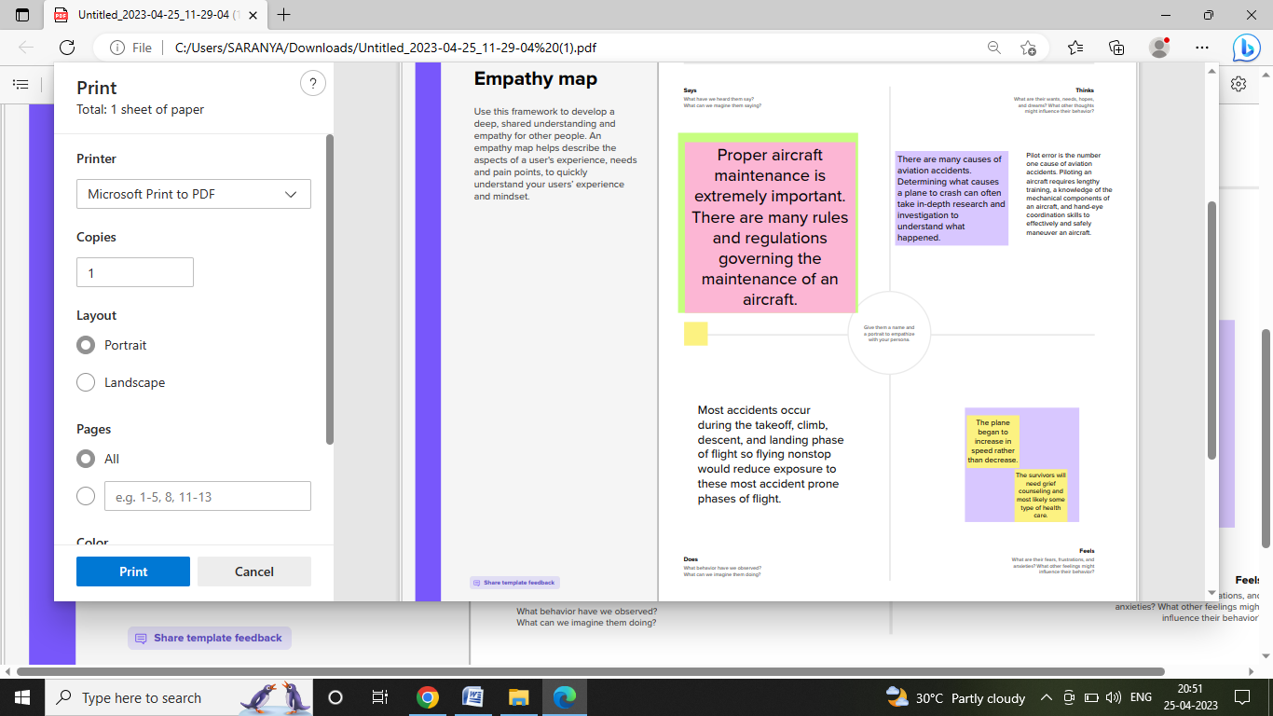

2.2 Ideation and brain storming map



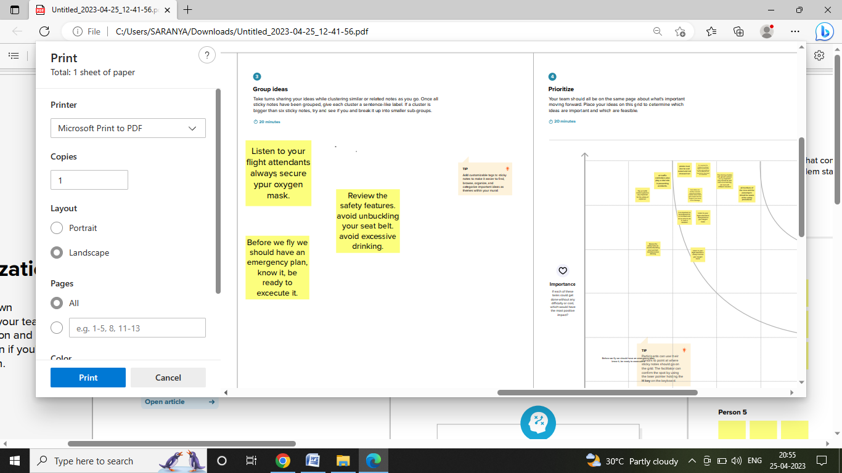

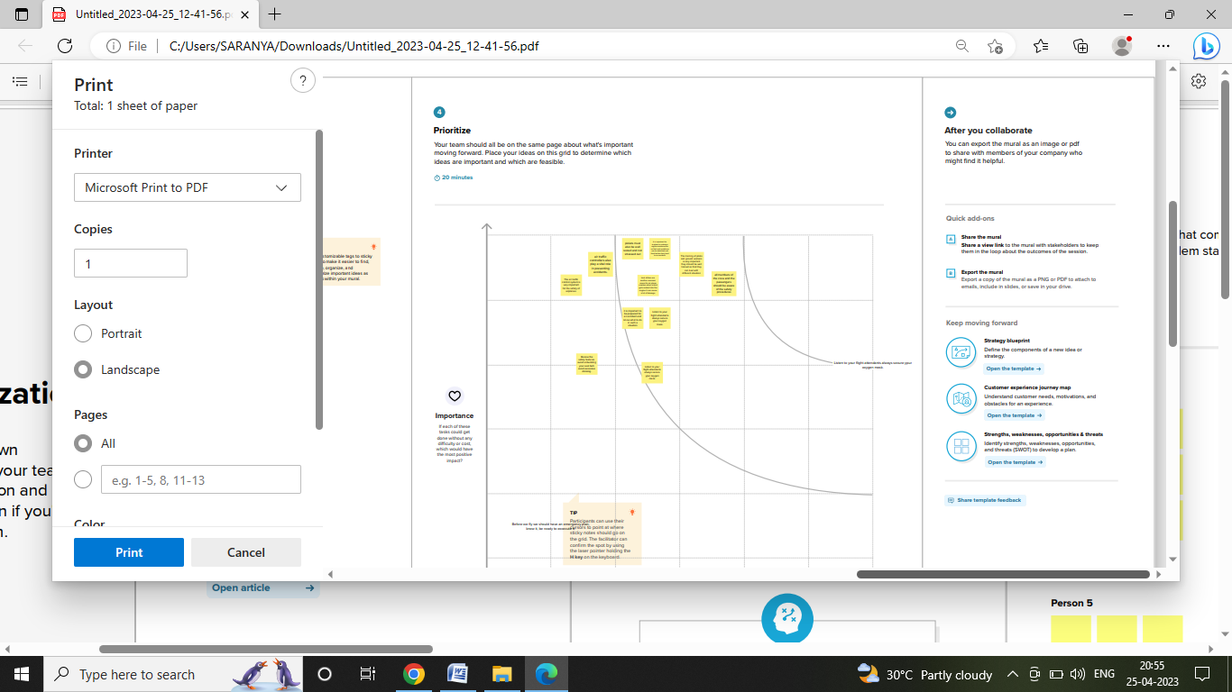

3 Result

> All civil and commercial aviation accident of scheduled and non scheduled passenger air liners worldwide, which resulted in a fatality

> all cargo, positioning, ferry and test flight fatal accident .

> all military transport accidents with 10 or more fatalities

> all civil and military airship accidents involving fatalities

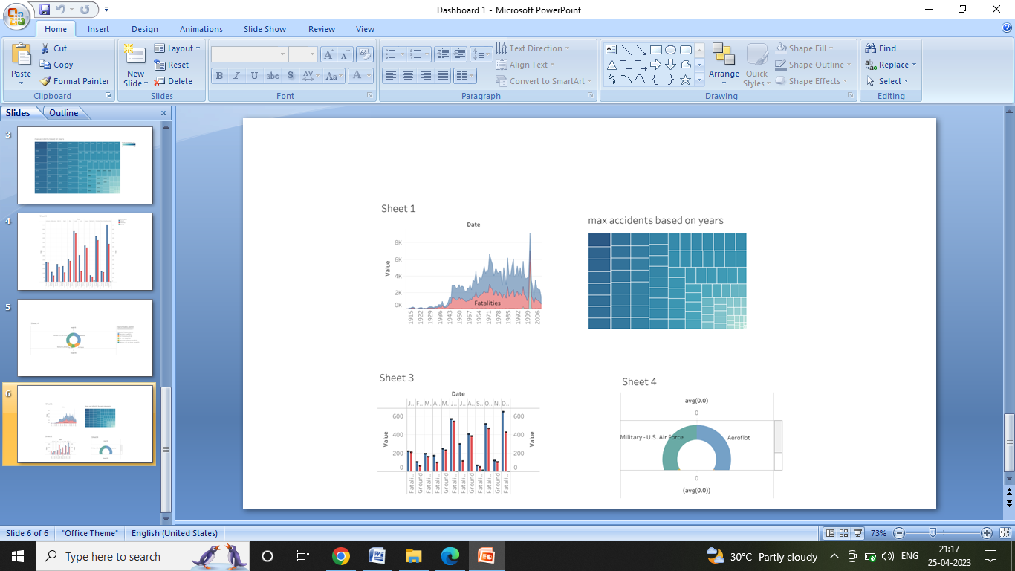

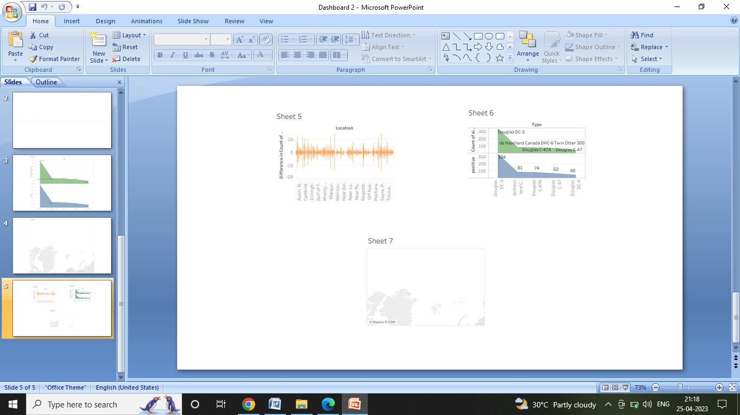4 Major reasons behind plane crashes

>weather conditions

>human error

>technical problems in air plane

>bird strikes

>mechanical problems in airplane

>mistakes by the ground workers

5 Preventive measures

* Improved training for pilots
* Proper maintenance
* Improve the air traffic control systems

6 conclusion

Overall, there are many different causes of plane crashes. By taking some preventive measures, the risks can be reduced. However, accidents can still happen even if all the safety measures are in place.

Therefore, it is important to be prepared for an accident and know what to do in such a situation. All members of the crew and passengers should be aware of the safety procedures so that they can act quickly and efficiently in the event of an accident.